**English 92**

**Research Project Handout**

**Name: ____________________________________________**

**Purpose:** This handout is designed to guide you through the research process by developing a research statement and then helping you search, identify, evaluate and locate 3 authoritative sources for your summary and final presentation/project.

|  |
| --- |
| **Checklist: Research Project Handout** |

* Fully complete and turn in this Research Handout.
* Attach a copy of the first page of a resource from a reference database.
* Attach a copy of the library catalog record for the book you choose.
* Attach a copy of the database record for the periodical article you choose.

|  |
| --- |
| **Checklist: Read Sources and Write Summary** |

* Highlight or underline and make marginal notes on the 3 sources you select.
* Summarize **3 sources** into a one-page summary. Make connections between sources and your research statement or question. See the *Summary Handout* for an example.
* Use the MLA format to create in-text citations and a Works Cited page. See the *Summary Handout* and the *MLA Guidelines Handout.* Attach the Works Cited page to your summary.

|  |
| --- |
| **Checklist: Presentation** |

* Organize all the information into a cohesive group presentation.
* Present to the class.

|  |
| --- |
| PART 1: State your Research Question or Thesis Statement and Keywords |

1. State your topic as a ***research question or statement***:

***Example:*** How does Julia Alvarez’s immigrant background and native language add interest and flavor to her novel, *In the Time of the Butterflies*?

|  |
| --- |
|  |

1. Write your keywords and search terms from the *Pre-Project Preparation* worksheet. You will be using these terms to locate resources.

|  |  |  |  |  |
| --- | --- | --- | --- | --- |
| **Main Ideas/Concepts** | | **Keywords, Related Terms or Synonyms** | | |
| 1 |  |  |  |  |
| 2 |  |  |  |  |
| 3 |  |  |  |  |
| 4 |  |  |  |  |

|  |
| --- |
| PART 2: Search for Background Information: Reference Databases |

|  |
| --- |
| C:\Documents and Settings\Owner\Local Settings\Temporary Internet Files\Content.IE5\TNC5LDC4\MCj03226990000[1].wmf  **STOP!!** Do not use Google or Google Scholar, use the ***Reference Databases*** to locate information. Our **first stop** is to locate *authoritative* background or overview information on our topics. |

There are three ***great*** full-text **Reference Databases** that will be useful for your project:

* **Gale Literature Databases:** Provides biographical information on authors and criticism on literary works. Includes journal articles, essays, and interviews.
* **History Resource Center: World:** An electronic reference library. It includes specialized encyclopedias, as well as journal articles, maps, charts and statistics.
* **CultureGrams:** Provides concise overview information on countries of the world. Includes information on demographics, culture, customs, politics and even recipes.

***Example:*** The main concepts I chose to search on are **Julia Alvarez**, ***In the Time of the Butterflies*** and the **Dominican Republic**.

|  |  |  |  |
| --- | --- | --- | --- |
| **Database Name** | **Search Term(s) or Phrase** | **Useful?** | **Why or Why Not?** |
| Gale | 1. Julia Alvarez 2. In the Time of the Butterflies | Yes | 1. Lots of biographical info on the author 2. Lots of literary criticism on this novel—and info on using Spanish! |
| History Resource Center: World | Julia Alvarez | Yes | Biographical information on the author—periodical articles and other resources. |
| CultureGrams | Dominican Republic | Yes | Background information on Dominicans, including religion and language. |

**Instructions:**

Select **Resources** from the library homepage (<http://library.whatcom.ctc.edu>), then **Article & Research Databases**.

1. Choose only ***one*** of the databases listed above and conduct a search on your topic. To search these databases, simply **select the main concept** from you reference question or statement. Generally, you do not need to combine search terms (Boolean searching) in these databases.
2. If you are unable to locate information on your topic, please ask for help, we may have to choose a different database or use different search terms.
3. **Print out** the first page of a useful document and attach it to this handout. To print the record, use the print icon in the upper-right of the browser bar. You may also click on File in the upper-left, then Print.
4. Using the *Evaluating Resources: Credibility Criteria Handout*, check the A.S.P.E.C.T. of your document and write down the reasons why you chose it.

Main concepts: ____________________________________________________________________

|  |  |  |  |
| --- | --- | --- | --- |
| **Database Name** | **Search Term(s) or Phrase** | **Useful?** | **Why or Why Not?\*** |
|  |  |  |  |

*\*If your chosen database was not useful, ask for help! We will select another database or revise your search term.*

Credibility Criteria: A.S.P.E.C.T.

|  |  |
| --- | --- |
| **Authority** |  |
| **Sources** |  |
| **Purpose** |  |
| **Evenness** |  |
| **Coverage** |  |
| **Timeliness** |  |

|  |
| --- |
| PART 3: Search for Information: Library Catalog |

|  |
| --- |
| C:\Documents and Settings\Owner\Local Settings\Temporary Internet Files\Content.IE5\TNC5LDC4\MCj03226990000[1].wmf  **STOP!!** Do not use Google or Google Book, use the ***Library Catalog*** to locate books. Our **second stop** is to locate an *authoritative* book on our topics or an aspect of our topics. |

**Instructions:**

Select **Library Catalog** from the library homepage (<http://library.whatcom.ctc.edu>). You will now use your keywords as search terms to locate books. You will need to refer to page 2 for your keywords.

1. Write down your search term(s): _________________________________________________
2. **Basic Search**: Type your term in the search box, within 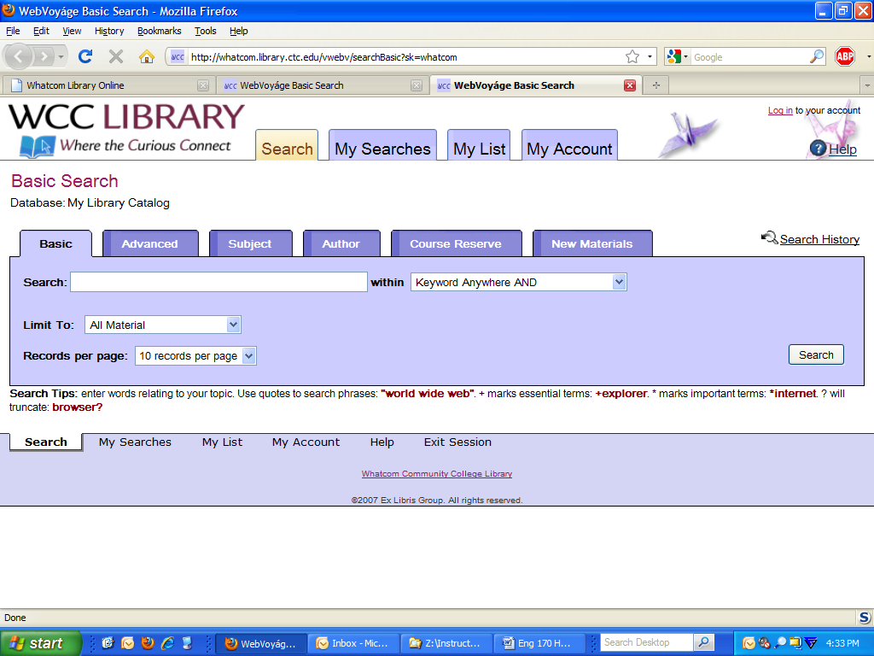. Click the  button.
3. How many book titles did you retrieve? ___________
4. Browse the selections, and locate a relevant title. Click on the title to see the full book record. Browse the chapter headings (if available) and the subject terms. (*If you do not find a relevant title, use other search terms and/or ask for help!*)
5. Write down the title, call number and location:

____________________________________________________________________________________________________________________________________________________________________

1. Write down the subjects:

____________________________________________________________________________________________________________________________________________________________________

1. **Advanced Search**: Click on the tab at the top of the screen. Now click on the 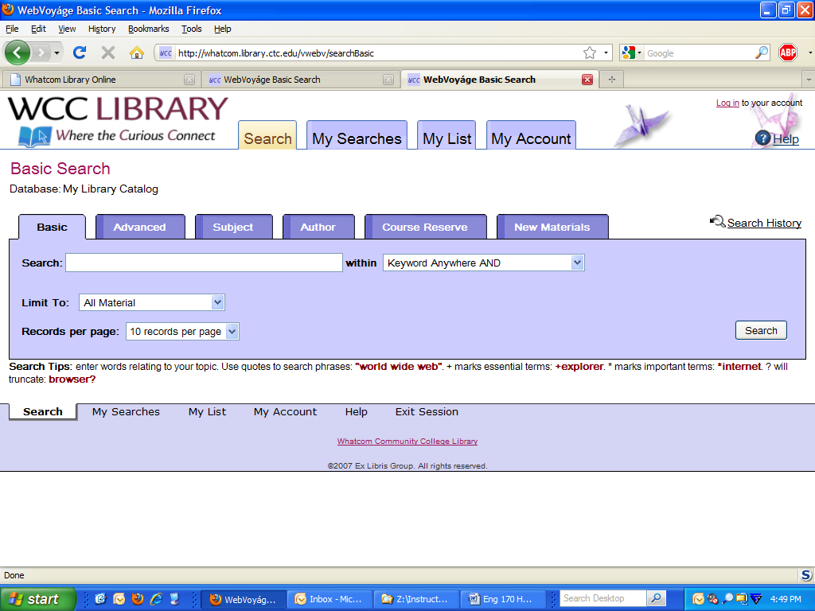tab. Combine your search with at least one more of your search terms. If you use a phrase, be sure to select “as a phrase” in the middle pull-down menu. If you want to look for your term in just the subject area, be sure to use the right-most pull-down menu to select 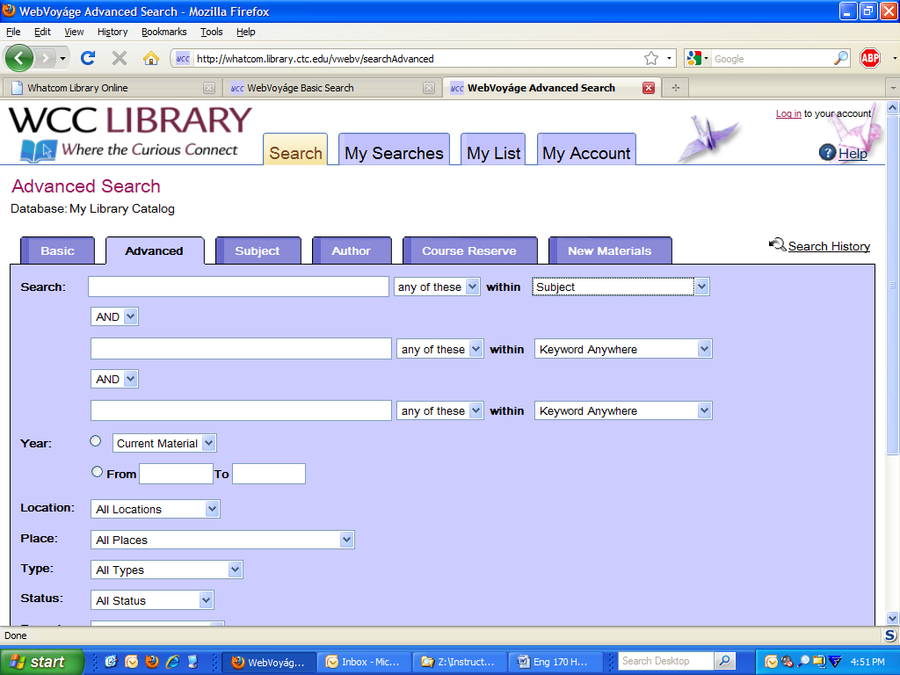.
2. Write down your search terms: __________________________________________________
3. How many book titles did you retrieve? ___________
4. Browse the selections, click on a title that looks relevant. Write down the title, call number and location:_____________________________________________________________________________________________________________________________________________________________
5. Write down the subjects:

____________________________________________________________________________________________________________________________________________________________________

1. Re-do your search with one of the subjects listed above, simply click on those words in the subject field or re-do your search by clicking on the tab at the top of the screen, and type in one of the subjects listed above.
2. Now browse the list of subjects. Click on the subjects until you find a book that looks relevant.
3. Write down the title, call number and location: ____________________________________________________________________________________________________________________________________________________________________
4. **Print out** a library catalog record for one relevant book and attach it to this handout. To print the record, use the print icon in the upper-right of the browser bar. You may also click on File in the upper-left, then Print.
5. Using the *Evaluating Resources: Credibility Criteria Handout*, check the A.S.P.E.C.T. of your book and write down the reasons why you chose it.

Credibility Criteria: A.S.P.E.C.T.

|  |  |
| --- | --- |
| **Authority** |  |
| **Sources** |  |
| **Purpose** |  |
| **Evenness** |  |
| **Coverage** |  |
| **Timeliness** |  |

|  |
| --- |
| PART 4: Search for Information: Periodical Articles |

|  |
| --- |
| C:\Documents and Settings\Owner\Local Settings\Temporary Internet Files\Content.IE5\TNC5LDC4\MCj03226990000[1].wmf  **STOP!!** Do not use Google or Google Scholar, use the **Article & Research Databases** on the library homepage. Our **third stop** is to locate *authoritative* articles on our topics. |

There are two ***great*** periodical databases for your topic. For this handout, we are going to use Ebsco. But, if you do not find an article in Ebsco, be sure to try your search in ProQuest and ask for help from a librarian.

* **Ebsco: Academic Search Premier:** Has full-text access to over 4,500 general and academic periodical titles
* **ProQuest:** [**Research Library**](http://proquest.umi.com/login?COPT=REJTPTEwMmEmSU5UPTAmVkVSPTI=&clientId=1971)**:** Has full-text access to over 2,600 general and academic journals plus abstracts and indexing for over 3,900 additional periodicals.

***Example:***  Search on your main concept first. My main concept is Julia Alvarez.

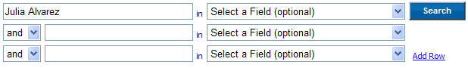

***Example:*** Create a Boolean search by adding a subject term from a relevant article or from your keywords you generated earlier. I used ***bilingualism***, one of my keywords that I also saw in the subject terms of a relevant article.

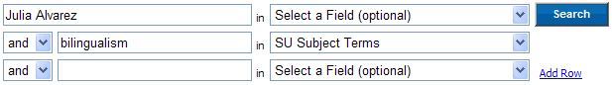

**Instructions:**

Select **Resources** from the library homepage (<http://library.whatcom.ctc.edu>), then **Article & Research Databases**. Under **General Purpose**, click **Academic Search Premier** or the word **EBSCO**.

* Write down your search term(s): ____________________________________________
* In the first box, type your first search term, do not select a field.
* In the **Limit Your Results** area, select **full-text**, click 

1. How many titles did you retrieve? __________
2. Locate one relevant article, write down the title:

____________________________________________________________________________________________________________________________________________

1. Click on the title of the article. Read the abstract and write down any useful subjects:

____________________________________________________________________________________________________________________________________________

1. Now revise your search by adding one of the useful subjects you located above, be sure to select 
2. How many articles did you retrieve now?__________
3. Review the list and select a relevant article. Write down the title of the article:

____________________________________________________________________________________________________________________________________________

1. Send the article to yourself via **e-mail**, click on the in the upper right corner. Be sure to select the **MLA** Citation format. Then, to see the MLA Citation, click on the  in the upper right-hand corner, then click on the yellow  in the upper right-hand corner.
2. **Print out** and attach the database record to this handout. Click on the title of the article, click on the  in the upper-right corner, select *Detailed Citation and Abstract* under the *Standard Field Format* pull-down menu, click on print.
3. Using the *Evaluating Resources: Credibility Criteria Handout*, check the A.S.P.E.C.T. of your article and write down the reasons why you chose it.

Credibility Criteria: A.S.P.E.C.T.

|  |  |
| --- | --- |
| **Authority** |  |
| **Sources** |  |
| **Purpose** |  |
| **Evenness** |  |
| **Coverage** |  |
| **Timeliness** |  |

|  |
| --- |
| PART 5: MLA Citations and the Works Cited Page |

As you locate information in various resources, be sure to collect the necessary information to construct your Works Cited page. It is a good idea to print out the first page of a database record or a web page. For online citation guides (MLA, APA, etc.), go to the library homepage (<http://library.whatcom.ctc.edu>), select **Research**, then **Citations/Plagiarism**.

|  |  |  |
| --- | --- | --- |
| **Resource** | **Citation Information Needed** | **What to Print** |
| Book | Author, Title, Date, Publisher, Place of Publication | Record from Library Catalog |
| Article | Author, Article Title, Journal Name, Volume, Issue, Date, Page Numbers, Database Name | Record from Database or First Page of Full-text Article |
| Web Site or Web Page | Author, Page Title, Publisher, Publication Date, URL (Web Address), Date of Access | First Page of the Web Site |

**Encyclopedia Article from a Reference Database**:

|  |
| --- |
| **Author Last Name, First Name (if given). "Title of Article in Quotes with All Important Words**  **Capitalized." *Title of Source (if given) Italicized with All Important Words Capitalized.* Day Month**  **Year: pages (if given). Vol. Number. Ed. Name of Editor in First, Last Order. City and State of**  **Publication: Publisher, Date. In *Name of Database Italicized.* City and State of Publication (if given):**  **Publisher (if given), Date (if given). Medium of Publication. Day Month Year of access.**  "Dominican Republic." *CultureGrams Online Edition*. ProQuest, 2010. Web. 20 Apr 2010.  "Julia Alvarez." *Encyclopedia of World Biography*, 2nd ed. 17 Vols. Gale Research, 1998. In *History*  *Resource Center*. Farmington Hills, MI: Gale. Web. 10 Feb. 2010,  “Julia Alvarez” *Contemporary Literary Criticism-Select.* In *Gale Literary Databases*. Web. 10 Feb. 2010. |

**Create your reference article citation:**

|  |
| --- |
|  |

**Book**:

|  |
| --- |
| **Author(s) last name, first name. Title of Book. Place of Publication: Publisher, Year of Publication. Medium of**  **Publication.**  Quintana, Alvina E., Ed. *Reading U.S. Latina Writers: Remapping American Literature.* New York:  Palgrave Macmillan, 2003. |

**Create your book citation:**

|  |
| --- |
|  |

**Magazine (Popular Article) from Ebsco or ProQuest:**

|  |
| --- |
| **Author(s) last name, first name. "Title of Article." Title of Periodical Day Month Year: pages. *Database Title.* Database Name. Web. Date of Access.**  Poniewozik, James. "TV Makes a Too-Close Call." Time 20 Nov. 2000: 70-71. *Research Library.* ProQuest. Web.  10 Feb. 2010. |

**Scholarly Article from Ebsco or ProQuest:**

|  |
| --- |
| **Author(s) last name, first name. "Title of Article." Title of Journal Volume.Issue (Year): pages. Medium of publication. Date of Access.**  Torres, Lourdes. "In the Contact Zone: Code-switching Strategies by Latino/a Writers." *MELUS* 32.1 (2007): 75-96.  *Academic Search Premier*. EBSCO. Web. 10 Feb. 2010. |

**Create your popular or scholarly article citation:**

|  |
| --- |
|  |

Eng 92 Kongshaug Spring 10 researchhandout.docx